Project Design Phase-II
Technology Stack (Architecture & Stack)

Date | 7 July 2026
Team ID | SWTID-2026-5632
Project Name | Visualizing Housing Market Trends: An  Analysis of Sale Prices and Features using Tableau
Maximum Marks | 4 Marks

Technical Architecture:
The Deliverable shall include the architectural diagram as below and the information as per the table1 & table 2
Example: Order processing during pandemics for offline mode
Reference: https://developer.ibm.com/patterns/ai-powered-backend-system-for-order-processing-during-pandemics/
Guidelines:
- Include all the processes (As an application Logic/ Technology Block)

- Provide infrastructural demarcation (Local)

- Indicate external interfaces (if any)

- Indicate data storage and components/services

- Indicate Interface to machine learning models (if applicable)

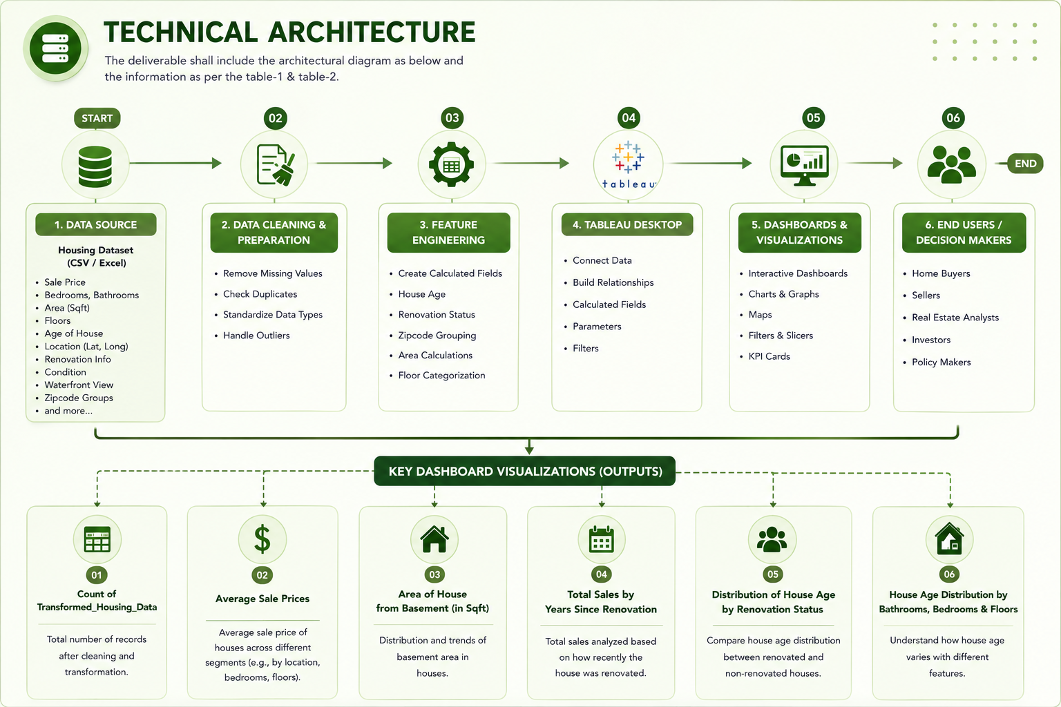Table-1: Components & Technologies:
S.No | Component | Description | Technology
1. | User Interface | Interactive dashboard used to explore housing market trends. | Tableau Dashboard
2. | Application Logic-1 | Data cleaning and preprocessing before analysis. | Tableau Filters
3. | Application Logic-2 | Feature engineering and calculated fields. | Tableau Calculated Fields
4. | Application Logic-3 | Interactive analysis using filters, parameters and charts. | Tableau Desktop
5. | Database | Stores the housing dataset for analysis. | CSV / Excel Dataset
6. | Cloud Database | Not used in this project. | N/A
7. | File Storage | Stores dataset and Tableau workbook. | Local Storage (.csv, .xlsx, .twb/.twbx)
8. | External API-1 | Not used. | Not Applicable
9. | External API-2 | Not used. | Not Applicable
10. | Machine Learning Model | Machine learning is not implemented in this project. | Not Applicable
11. | Infrastructure (Server / Cloud) | Project developed and executed on a local computer. | Windows PC, Tableau Public

Table-2: Application Characteristics:
S.No | Characteristics | Description | Technology
1. | Open-Source Frameworks | Dataset prepared using Microsoft Excel | Microsoft Excel
2. | Security Implementations | Read-only project files with local system security | Windows File Permissions
S.No | Characteristics | Description | Technology
3. | Scalable Architecture | Architecture can easily support additional housing records, dashboard sheets and calculated fields without redesigning the system. | Tableau Public, CSV/Excel Dataset
4. | Availability | The dashboard is available whenever the Tableau workbook and dataset are opened on the local computer. Internet is only required for publishing to Tableau Public (if used). | Tableau Public
5. | Performance | Efficient processing of housing data using Tableau's in-memory engine, filters, calculated fields and optimized visualizations for faster dashboard response. | Tableau

References:
https://c4model.com/ https://developer.ibm.com/patterns/online-order-processing-system-during-pandemic/ https://www.ibm.com/cloud/architecture https://aws.amazon.com/architecture https://medium.com/the-internal-startup/how-to-draw-useful-technical-architecture-diagrams-2d20c9fda90d

